Bahria University,

Karachi Campus



LAB EXPERIMENT NO.

11

LIST OF TASKS

|  |  |
| --- | --- |
| TASK NO | OBJECTIVE |
| 01. | Write a program in MIPS assembly language that provide the sum from 1 to 99 using for Loop. |
| 02. | Write a program in MIPS assembly language that provide the subtraction from 20 to 10 using inverse for Loop. |
| 03. | Write a program in MIPS assembly language that provide the subtraction from 1 to 50 using for Loop. |
|  |  |

Submitted On:

17/12/2019

**Task # 1:** *Write a program in MIPS assembly language that provide the sum from 1 to 99 using for Loop.*

**Code:**

.data

output: .asciiz "Sum of number from 1 - 99:\n"

.text

la $a0,output

li $v0,4

syscall

li $t0,1

loop:

add $t1,$t0,$t1

addi $t0,$t0,1

blt $t0,100,loop

end:

move $a0,$t1

li $v0,1

syscall

**Output:**

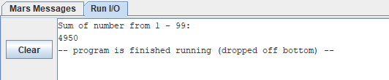

**Task # 2:***Write a program in MIPS assembly language that provide the subtraction from 20 to 10 using inverse for Loop.*

**Code:**

.data

output: .asciiz "Subtraction of number from 20 - 10:\n"

.text

la $a0,output

li $v0,4

syscall

li $t0,40

li $t5,20

loop:

sub $t0,$t0,$t5

addi $t5,$t5,-1

bge $t5,10,loop

end:

move $a0,$t0

li $v0,1

syscall

**Output:**

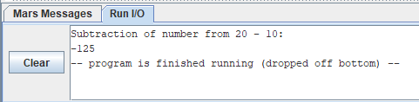

**Task # 3:** *Write a program in MIPS assembly language that provide the subtraction from 1 to 50 using for Loop.*

**Code:**

.data

output: .asciiz "Subtraction of number from 1 - 50:\n"

.text

la $a0,output

li $v0,4

syscall

li $t0,1

loop:

sub $t1,$t1,$t0

addi $t0,$t0,1

blt $t0,51,loop

end:

move $a0,$t1

li $v0,1

syscall

**Output:**

